**INDIVIDUAL ASSIGNMENT 1: NEEDS ASSESSMENT**

Our senior design project is centered around the modelling of cancer metabolism. Recent studies demonstrate that changes in cell metabolism is a primary result of cancer, contrary to early biochemical perspectives that attributed the changes as secondary results1. Thus, drugs targeting cancer metabolism, commonly through inhibition, have become popular. Broadly, the objective of our project is to design optimal strategies for novel therapeutics by modelling central cancer metabolism. By targeting well-characterized enzymes key to cancer metabolism, we hope to find non-intuitive connections revealed through modelling, that results in inhibition of cancer growth.

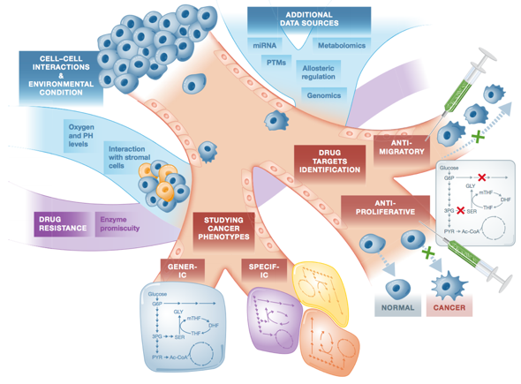 The realm of cancer metabolism is extremely broad2 (**fig. 1**). To that end, our design focuses on the drug targets identification pathway of cancer metabolism modelling. In particular, we are interested in cancer cell response to certain drug treatments. To achieve this, we will use sequence analysis to identify key mutations in different types of cancers in the context of specific metabolic enzymes. Then, we will use molecular dynamic simulation to understand, on the structural level, what alters the behavior of the mutated enzymes. Finally, we will use kinetic modeling to test the mutated enzymes’ response to drug treatments. We have spent our time extensively learning about the aforementioned modelling techniques. Thus, we haven’t chosen a particular enzyme/pathway to exploit, but potential candidates we are considering are: PKM2, ICDH, Serine pathway, and folate-dependent NADPH production.

**Figure 1:** Current and future applications of genome-scale metabolic modellings2.

Our modelling of cancer metabolism is limited by the mathematical assumptions made during the modelling process. A method commonly used to study metabolic pathways is the aforementioned constraint based modelling. Specifically, we explore flux balance analysis of metabolites within our system3. Flux balance analysis compares the steady state values of metabolites after certain perturbations (such as inhibition), and as a result enzyme kinetics are not incorporated into the simulation. Thus, our modelling is limited by the assumptions made using flux balance analysis of basing our conclusions on steady state values that do not take into account the kinetic parameters of relevant enzymes.

There are several glucose uptake inhibitors that target cancer metabolism that have appeared in pre-clinical trials from big pharmaceutical companies. By developing a robust workflow to test cancer response to drug treatment *in silico*, drug discovery will be expedited and resources will be saved. In addition, the identification of drug response to specific enzyme mutations in individuals is also in line with precision medicine, allowing doctors to prescribe certain drugs based on the patient’s cancer mutation. The success of our project will benefit the pharmaceutical industry and will cascade down to ultimately benefit cancer patients seeking proper treatment due to increased efficiency of drug discovery.

Our project will be successful if we are able to model cancer cell response to various types of drug response based on their enzymatic mutations. The idea is to exploit an enzyme in a particular manner that will induce a positive response that is non-intuitive, such as the inhibition of nucleotide synthesis specific to cancer cells in a detached pathway.

**REFERENCES:** [1] Ward, P. and Thompson, C. (2012). Metabolic Reprogramming: A Cancer Hallmark Even Warburg Did Not Anticipate. Cancer Cell *21*, 297-308. [2] Yizhak, K. et al. (2015). Modelling cancer metabolism on a genome scale. Molecular Systems Biology (online) *11:817*. [3] Orth, J. D., Thiele, I., Palsson, B.O. (2010). What is flux balance analysis?. Nature Biotechnology *28*, 245-48.